

**A Portfolio**

On

**Community Outreach**

Submitted by

**xxxxx**

**A230xxxxx**

**M.Tech CSE**

**20xx-20xx**

**October 20xx**

**Chapter 1**

**Introduction**

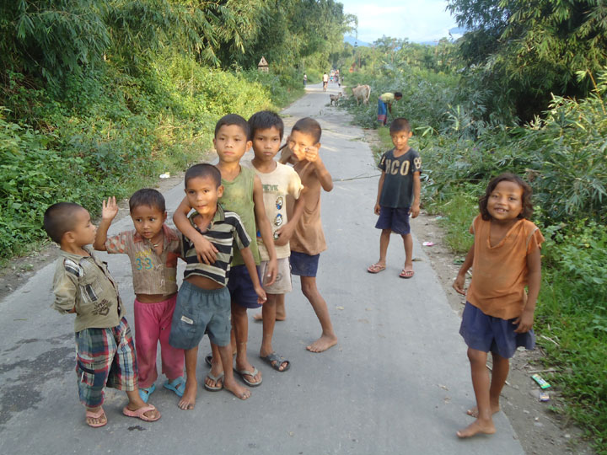Do you believe that the value of life is just minting money and to take care of those whom you love. Or did you believe that life is worth living in the schedules made by destiny. Today We are living and counting days which only aim to improve our life and those who matter. While we go to temples and pray for self and live selfishly, their those who don't have sleepers to put on or a grain to live for.

Many NGO's are working hard to bridge the gap between the selfish rich and the forgiving poor through different schemes aligned with the government. But to what extent they are effective depends totally on the support of the people and their contributions.

It seems quite easy to debate and show concern for those who are not equal. But to think as a community and accepting the responsibility of helping others is difficult in practice. Through the proper guidance of a community outreach coursework we students have gained the insight and the need to be responsible for our community and understand that to help others selflessly without any expectations, royalty or fame is the ultimate path to self satisfaction. The fact that most NGO's operate in and around the city of Delhi - NCR, we decided to access a local village which is totally cutoff from the city roads.

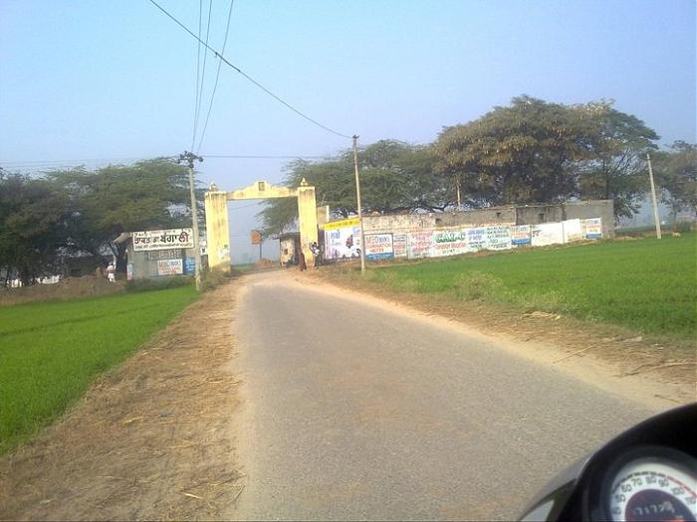Through our efforts and god's will we were able to identify a village that was rooted with orthodox traditions and beliefs which prevented child education and women welfare. Knowing that conditions will not favor easily, we as a team set out for Khusrupur, a remote village 28 K.M. from Bulandshahr in Uttar Pradesh. Luckily we were able to align ourselves with **"Adhyatmik Seva Mission Trust. "** who accepted our efforts to improve the conditions of education and health. The following members along with myself have planned to help the village children in terms of education and health and promoting awareness about the importance of women health and improvement in the male dominated village of Khusrupur.

   

Sohxx Cxx Nxx Lixx

Over the span of three months we have planned approximately twelve to fifteen visits in the different sectors of the village where each member of the team has followed a set of responsibilities assigned by the supervisor.

Apart from the supervision of our NGO representative. We underwent a proper coursework on Community Outreach headed by our faculty advisor. Over the span of three months we understood the aim, key learning, principles and the knowledge of engaging communities that will be discussed in the forthcoming chapters .

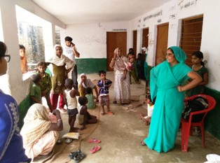

**Chapter 2**

**Understanding Community Outreach**

In this section we try to understand the objective and ethos that community outreach has embedded within us. The ultimate aspect of community outreach is to feel the responsibility of serving the society in terms of underprivileged welfare or through any honest methods necessary that can promote a positive impact on the lives of the challenged.

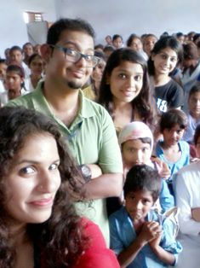**1. Key Learning :** Community Outreach involves the donation of time and or resources for the benefit of the community or its institutions including NGO’s and CBOs.

**2. Aim :** Community Outreach Program enable us to explore various volunteer opportunities and learn more about the local institutions and civil society.

**3. Human Values :** There are five stem values and many sub-values or virtues that come from Together they make up the tapestry that forms an individual of character, containing all that makes a human noble, caring and kind. The primary five are:-

* Love
* Peace -Using the tool of the mind
* Truth -Using the power of intellect
* Non-violence -Awakening the spirit within
* Right Conduct -Using the tool of the body

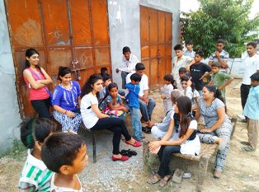**4.** **Goals**

* Enhance Community Awareness
* Increase the visibility of program
* Broaden community support
* Engage new partners/ stakeholders
* Improve knowledge and attitudes and behaviors
* Develop responsible citizenship

**5. Principles Followed**

* 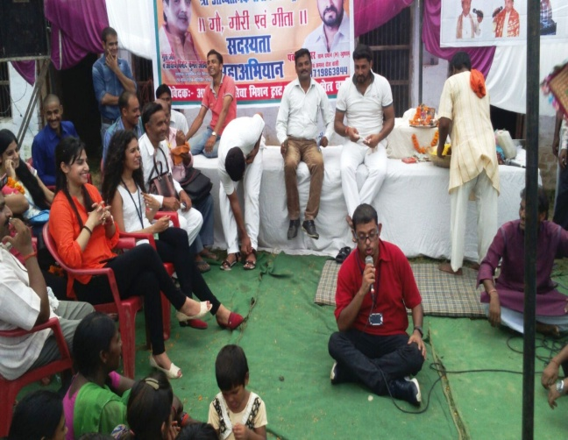Display respect for Individuals and value their worth and dignity.
* Display respect for culture and beliefs of the reach out groups/persons.
* Do not impose- accord persons the right to self determination based on informed choice.
* Do not create dependency in the populations served but promote self reliance in the community served.
* Maintain confidentiality of clients helped/supported.
* Do not criticize the populations you work with but be supportive and empowering.
* Display non judgmental attitude.

**6. How to build rapport**

* Building rapport/trust within the community is a critical prerequisite to conducting community outreach.
* Building rapport is helpful and contributes to the overall safety of the outreach worker during the field visits.
* This is a time consuming task and an on-going process.
* The basic strategies should be applied in order to build trust and deliver services are displayed in the process chart.

**7.** **Understanding Community Barriers**

* Stigmas, myths and misconceptions
* Behaviors and Perception
* Politics
* Lack of support
* Lack of trust
* Lack of funds

**8. Do's &. Don'ts**

The following table describes the basic points to follow or avoid doing while performing any activity at work site.

|  |  |
| --- | --- |
| Do's | Don'ts |
| Do conduct needs assessments | Do not wear expensive clothes, jewelry or uncomfortable shoes. |
| Do be flexible in scheduling. |
| Do carry identification at all times. |
| Do accept offers of help from community residents. | Do not carry valuables or large amounts of money, or take your wallet out. |
| Do have contingency plans for emergencies and dangerous situations. | Do not make promises in the community that you cannot deliver. |

**Chapter 3**

**Planning For The Unplanned**

In this section we will discuss the goals and a proper strategy to identify the factors surrounding the village that force children to succumb into child labour and the poor health of the villagers especially women.

**1. Goals**

It is well said that without vision no man can fulfill a journey. To us clear goals are very important for the administration and management of resources to improve the lives of countless people in minimal time. So before planning strategies, we ensured to identify the following goals to follow:

* To understand the working of an NGO in a remote work site.
* To identify the problems a child labour or a malnourished women faces.
* To understand the ethos of community outreach and help by doing the needful.
* To understand and self evaluate our position w.r.t the villagers. by giving solutions.
* To wake up others and aware them about resolving unorthodox traditions.
* To setup a minimal infrastructure in the village in terms of education and welfare.
* To create an opportunity to serve selflessly.

**2. Schedules and Activity**

We discussed our schedule and plans of action under the supervision of our NGO coordinator and faculty advisor through a schedule-activity table.

|  |  |
| --- | --- |
| Date | Activity |
| July 16 | Introductory class to community outreach |
| July 30 | Formulation of groups and understanding the objectives. |
| August 6 | First meeting with NGO coordinator |
| August 13 | 1. Visit Khusrupur for a single day to understand village community. 2. Discuss village issues with the village panchayat and sarpanch. |
| August 20 | Submit a preliminary report about village demographics, culture and problems to NGO coordinator. |
| August 22 - 23 | 1. Visit Khusrupur for Survey and problem description. 2. Interact with child labors and village families. 3. Distribute of survey forms and collection of data. 4. Meet the members of village panchayat and NGO volunteers. |
| August 24 - 30 | Fund collection from various sources like friends , relatives, neighborhood and startup organizations under CSR scheme. |
| September 3 - 8 | Data synthesis from survey. Solutions to be formulated with NGO coordinator and faculty advisor. |
| September 10 | Monthly report to be submitted to NGO coordinator. |
| September 13 | 1. Visit Khusrupur and started implementing solutions. 2. Motivate families to support their children for education 3. Observe hygiene standards 4. Visit local school in Kesair village and interacted with headmaster and staff. |
| September 17 | Discuss with NGO volunteers and coordinator about further plans. |
| September 18 - 21 | Revisit Khusrupur and Kesair village to implement final phase of our plans which include:   1. Re-enrolling village children who had left studying due to financial problems. 2. Setup of tuition center with voluntary teaching for children with no education. 3. Distribute mosquito nets in dengue/malaria affected sectors. 4. Setup of barn for cows to be maintained and matured for milk, cow dung. 5. Distribute pamphlets to aware the village crowd about hygeine. 6. Adopt a child for lifetime education till class 12th |
| September 23 | Poster presentation |
| October 1 | Progress report to be submitted to faculty advisor with summary of work done. |
| October 7 | Final meeting with NGO coordinator to crosscheck plans and devise future contributions. |
| October 10 | Discuss and agree on a future plan for miniature bio-gas plant along with dynamo generator to produce electricity for the village school and homes. NGO coordinator and IGL representative plan to meet the village sarpanch regarding to mutually agree for cow dung and waste supply.  Status : On progress  Cost: Rs 2.7 lacs INR |
| October 15 | Discuss and agree on developing a preliminary design for solar panels to be installed in 3 buildings to support road lights and barn by joining hands with M.Tech Solar & Power Engineering students of amity. The sarpanch along with the NGO and classified government officials have planned to install two 20 K.W. panels and halogen bulbs across the roads. The design will be done by M.Tech Solar students supervised by their faculty. On approval the project fund will be shared on 70-30 basis where 70% will be funded by government and the rest by NGO.  Status : On talks, however design work is on progress.  Estimated cost : 6.5 lacs INR |
| October 17 | 1. Monitor all plans ensuring they are successfully completed with hope that the two big projects are completed on time. 2. Draft final report start. |
| October 19 | Final report submission. But the work will never stop ! |

**3. Roles and Responsibilities**

Our coordinator had assigned us different roles based on our capabilities judged through a formal interaction at their head office in Punjabi Bagh.

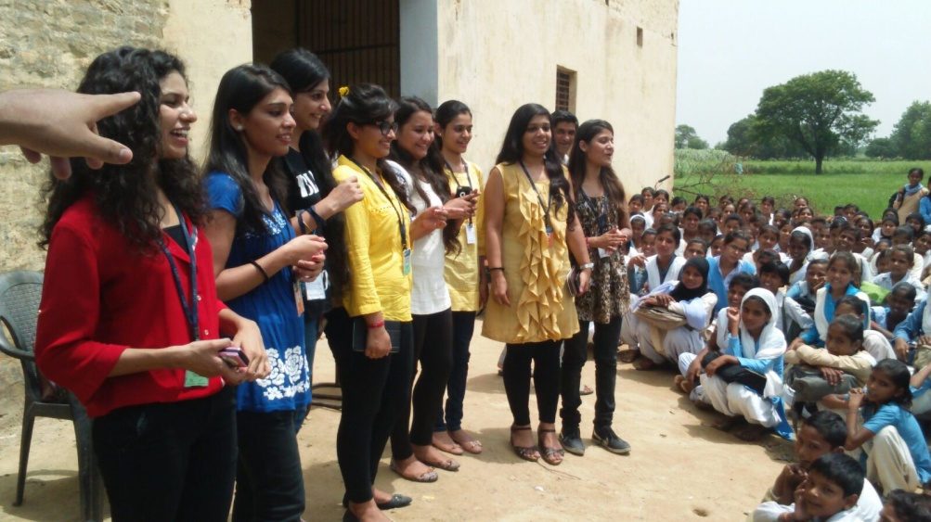

Following responsibilities were assigned to me during my tenure as a volunteer:

* To apply my knowledge and presence of mind and play the role of head volunteer.
* To distribute survey forms and gather data.
* To identify and collect funds from various sources.
* To determine and plan opportunities to assemble masses.
* To identify the key problems and coordinate the team of volunteers.
* To plan decisions and address the villagers with simple solutions.
* To dedicate my time to teach the uneducated.
* Help and support anti-domestication of women.
* Coordinate and become an access point between NGO and the villagers.
* To identify and spread the concept of health and hygeine among villagers.
* To identify people who can adopt and support child education.

**Chapter 4**

**Surveying The Ignored**

One of the key aspects to identify any problem and determine solutions is to make data driven decisions. In any unknown scenario it is advisable to understand the situation. But in order to do so one needs information. This information can be gathered using many surveying techniques like questionnaires or form filling or interviews. But when it comes to gathering data about a village as big as 7 colonies, it becomes a daunting task.

In our case the most fundamental problem was that we were facing a village community with literacy rate at the lowest. Very few people actually knew how to read and write. Luckily we had a good number and also the support of the village panchayat. Some of the techniques of surveying we adopted are:-

* Interview with Sarpanch.
* Form filling by volunteers on behalf of villagers.

We have divided this chapter based on the results of forms, interviews and key observations. A sample survey form has been enclosed in the appendix for reference.

**1. Data from Interview**

The main aim of the interview with the village Sarpanch was to collect information regarding village infrastructure, education level, sources of income etc.

|  |  |
| --- | --- |
| Major Source of Income | Farming |
| No. of Schools | 1 (Not functioning) |
| No. of Clinics | 1 (No doctor visits) |
| Administrative Building | No |
| Electricity | 4 hours/day |
| Water Supply | Village Well (2) |
| Hygeine Level | Pathetic |
| Child Labour | Preferred over education due to more money intake. |
| Communication Facility | Not even a post office. Mobile phones is a big luxury. |
| Average Family Income  (Monthly) | Rs 150 - 1000  During drought income decreases by 50% |
| Granary | No |
| Barn | No |
| No. of deaths due to improper health facilities | Every month atleast 6 deaths due to dengue/malaria/typhoid or jaundice |
| Connectivity with nearby city | Accessible but poor road infrastructure. |

**2. Data from form filling**

To achieve a more clear insight we planned to collect data from the villagers. I personally divided the village into four sectors and setup camps where villagers can describe their situation. The form was typed in Hindi so it was easy to make them understand what we need. Following information after thorough analysis was mined out from the villagers.

2.1. Population Distribution

Based on the inputs received from the families along with a thorough analysis, we tried to understand the family demographics by plotting a population distribution in terms of gender, and age. Khusrupur is a core village of U.P. and thus we found it was mainly promoting a **male dominated society.**

|  |  |
| --- | --- |
| Average age of men | 34 |
| Average age of women | 26 |
| Age of marriage for men | Between 21 - 24 |
| Age of marriage for women  No. of children per household | Between 16 - 21  Minimum: 2 Maximum: 6 |

The next statistics that showed alarming results was how employment affected the aspect of having children in a family. The bar diagram on the right helped us to understand the following key points:

* Higher the income of family lesser number of children in the family.
* Education affect birth control as families with no education give more births.
* Each family has more number of female child as compared to male child.
* More numbers is equal to more income.

2.2 Sources of income

We mapped the various occupation that follows under the village demography and mapped it with the average income as follows:

**Factors affecting income**

**Health**

No. of members

Women work in fields with **lower wages.**

Almost 80% farmers are in **debt**.

Income is **not permanent**

Farm **land is mortgaged** by almost 63% of the total farmers

Lack of skills other than farming which is inherited from generations

2.3 Education

The disappointing factor that has hold the village back from progress is education. One school is not sufficient to cater the needs of almost 3500 and more children. Following details emerged after the analysis of form data regarding education.

**Factors that affect education in the village**

Forced **labour**.

**Insufficient capacity** of village school.

**Lack of infrastructure** and **quality teachers**.

**Cannot afford fees** for all the children in a family.

Nearest alternative : **42** K.M **away**

Some of the key observations are:

* Girls are not sent to school since they are suppose to do household chores and get married as soon as possible.
* Boys on the other hand are not interested in pursuing education.
* Parents don't send even a single child since they fear all the siblings will wish for education.
* More number of children in field will bring more income.
* Parents force and promote child labour.
* Half of the village children suffer due to lack of any other schools.
* One school in the village hence higher fees charged by headmaster.
* Those studying don't even know how to spell basic letters.
* No knowledge of basic subjects since teachers don't come to school.

After a proper interaction with the school children and staff of the single school, we observed and collected the following information.

|  |  |
| --- | --- |
| Number of children in the village | 12,256 |
| Number of children studying | 4,256 |
| Number of boys studying | 3654 |
| Number of girls studying | 602 |
| Number of classrooms | 5 |
| Number of open classrooms | 3 |
| Infrastructure Level | No electricity, sanitation, education till 8 std. |
| Number of schools in the village | 1 |
| Mid day meals | No |
| Extracurricular activities | No |
| Number of staff (Academic) | 7 |
| Number of staff (Non academic) | 3 |

2.4 Health

Health is wealth. It is true that without any proper medication or diet one cannot simply deny

death. In Khusrupur the health conditions are pathetic. In almost every street of the village

you will find malnourishment has grasped the villagers especially women and children. Here we

were able to understand the reasons for such scenario through the following analysis:

**Factors that lead to poor health**

Families able to have only two meals a day.

Women eat last and the least.

Food stress is high due to high population.

Lack of hygeine and sanitation facility.

Local clinic infrastructure not good.

Low income.

Some of the key points observed in terms of health are:

* Females don't eat properly since the male members enforce their authority to eat most.
* Doctor visits clinic twice in a month.
* No pharmacy to provide medicines.
* Lack of awareness regarding proper sanitation techniques.
* No cheap alternative as doctor charges fees from locals.
* No clean water as wells are polluted.
* Most members of the family don't know about polio or basic vaccines.
* Death rate is increasing and the major contributor is dengue and malaria.

Based on the above statistics we plan our strategies for two important areas i.e. health and education. In next chapter we will discuss the work done so far to improve somewhat conditions of the villagers along with some future work.

**Chapter 5**

**Working for Impact**

After many brief visits and briefings with the village environment of Khusrupur. We are now down with following a strict schedule to improve health and education in the village. On a personal level the following flowchart has been found effective enough to start with implementation plans:

Based on the capacity of resources I have been able to concentrate on the education part meanwhile feeling responsible for improving the health conditions to some extent through prevention. with the help of our team.

**1. Health**

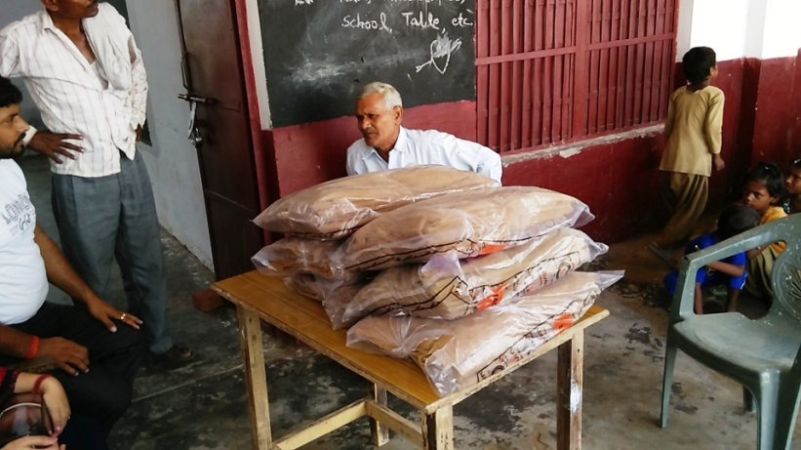In order to support prevention of disease elements spreading in the environment. Me and my team members decided to distribute mosquito nets for the children since they were the most targeted lot for infection.

Approximately two hundred mosquito nets where distributed among the children and more are planned to be distributed in the near future. In two months we have been able to cover 60% of the village.

Next we have spread awareness across the village with the help of pamphlets and through a social gathering discussed different hygiene techniques and how to have a proper diet.

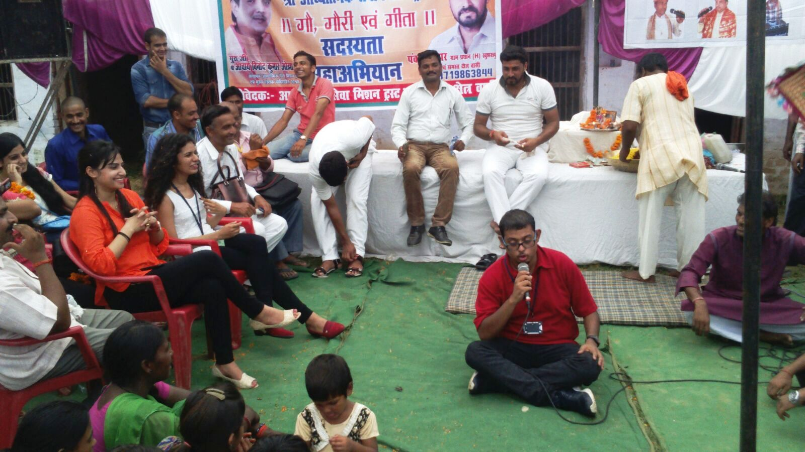

Let me share the impact of promoting health and hygiene in a remote village. According to the statistics of previous **25 day**

* 2 people have been diagnosed with dengue instead of 7
* Children are aware of good health practices and motivated to promote them
* 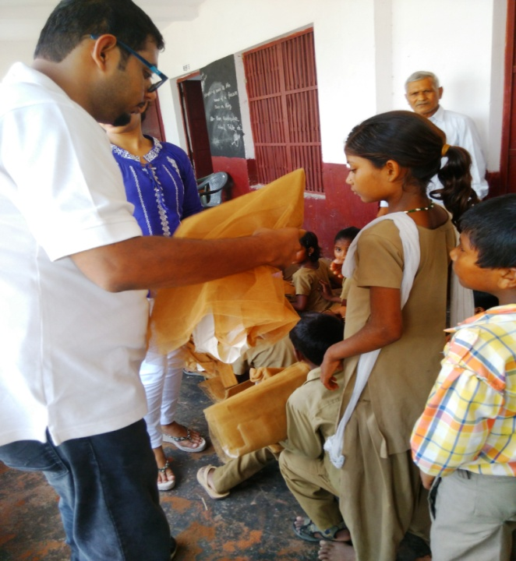Women are now more careful about their diet and men of the family have been doing well to take care of them.
* Two medical interns have been hired in the vicinity providing four visits a week under the supervision of local doctors.
* Polio camp soon to be organized in the month of November.

An article regarding good health practices was also published in the local daily mentioning the contributions of the NGO and its volunteers.

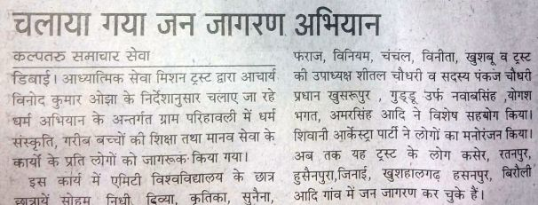

**2. Education**

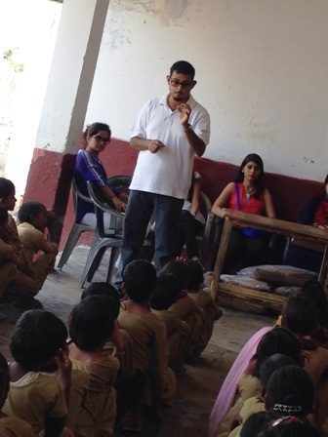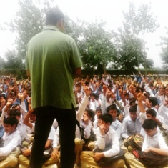**When you are educated.**

**You should practice enrichment.**

**When you feel enriched.**

**Try sharing.**

**Once you share you grow.**

**Grow not as a professional but as a good human being.**

Throughout our field work it was important to take education reforms in the village with the highest priority. We went to households and talked to villagers to send their children to study rather than growing crops. The following work was done to breach the gap of non education among villagers:

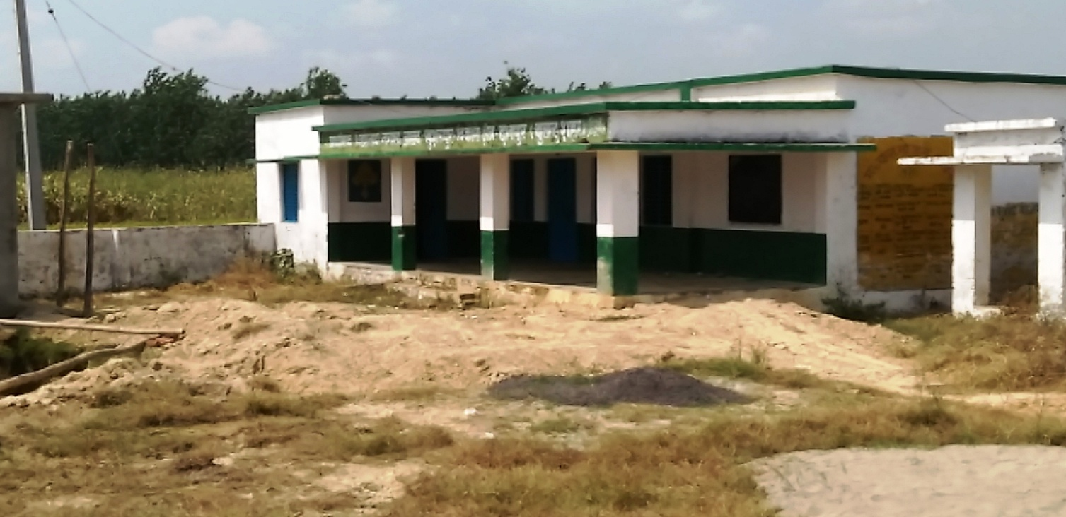

This is one of the recent sites selected and extended for the **55 students**. We are happy to say that parents are sending their children in more numbers than ever before. There has been an increase in the number girl students and we are focusing towards women empowerment.

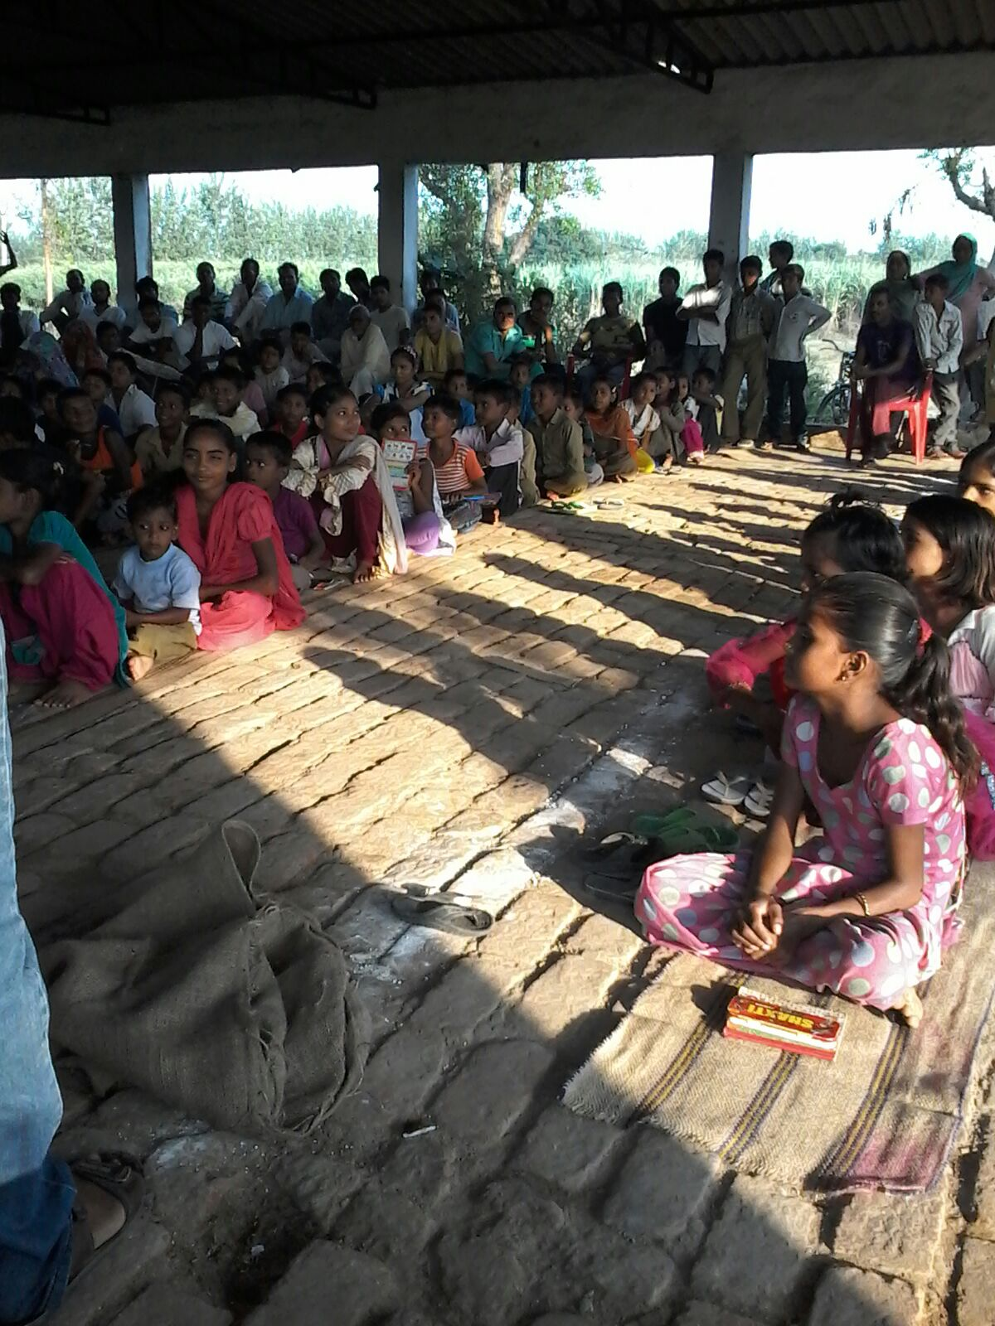

* Awareness about governmental education schemes where children can be benefited with low fees.
* Funds deposited in the local school for approx 10 students with annual subscription of Rs 2400 for lifetime.
* Re admission of 55 students over the span of three months.
* Setup of tuition center with a capacity of 200 students. All children for whom we could not create opportunities for schooling can avail free tuitions to prepare for 6th standard Navyodya Entrance Exam.
* Introduce scholarship schemes to motivate children and families.
* Efforts to abolish child labor through nukkad natak in village school.

**Chapter 6**

**Future Work**

After proper analysis and implementation of various strategies to improve the state of children and women. We have planned to contribute in production of bio-gas and solar energy in association with the government and corporate CSR funds. In reality we have planned a small biogas plant that will supply natural gas and electricity since the village offers tons of waste produce. IGL representatives along with NGO and village panchayat have already completed the talks and work is on progress. The plant is estimated to be completed by end of 2016 in exchange of continuous supply of fresh cow and human waste. IGL engineers have started designing and soon we are expected to provide electricity to almost 15% of the village.

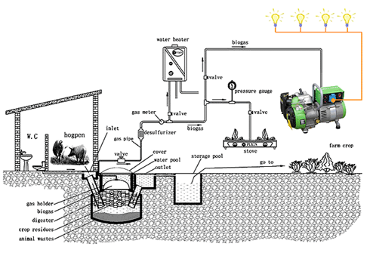

**Chapter 7**

**Conclusion**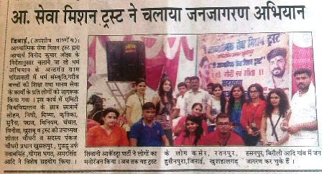

Community Service has no full stop. This outreach coursework has successfully ensured that as future professionals we should be obliged to help others not only in terms of money but through physical and mental support. Today the people of Khusrupur are happy and the fact that we have started to feel as if these people are of our own. As a family takes care of its members, similarly me and my friends have vowed to help not only these villagers but anyone who is genuinely in need. If you shower care and respect, you will be rewarded with a sweet smile.

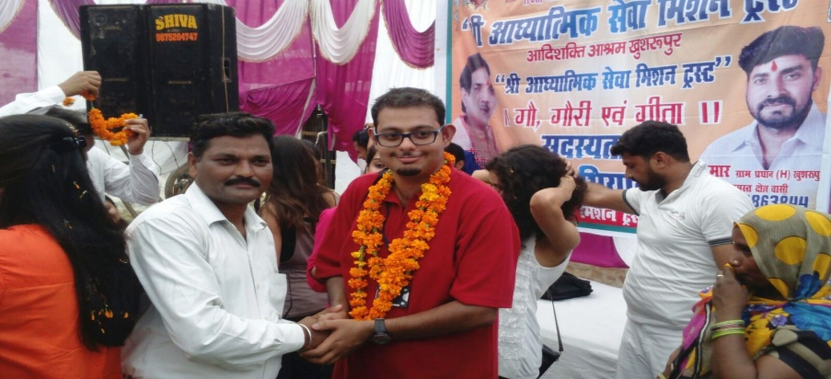

**Appendix**

**1. Sample Survey Form**

कम्युनिटी आउटरीच सर्वे फॉर्म

दिनाक : ___________________

१ आपके परिवार मे कितने लोग है ? _______________________

२. आपके परिवार मे कितने बच्चों है ? ______________________

३ क्या आप बच्चों को स्कूल भेजते हैं ? _____________________

४ कितने लड़के और लडकिया है ? _________________________

५ क्या आप लडकियो को स्कूल जाने देते है ? _________________

६ कितने साल के है आपके बच्चे ? _________________________

७ अगर आपके बच्चों को मुफ्त शिक्षा दिजाये तो क्या आप बच्चों को पढ़ने देंगी ? ____________

८ क्या आपके घर मे बिजली की कनेक्शन है ? _____________

९ क्या आपके घर मे पानी की व्यवस्था है ? _______________

१० माता पिता के रूप से आप क्या उम्मीद करते है गाँव के प्रधान से ? ___________________________________________________________________________________________________________________________________________________

११ आपके यहाँ कोंसी बीमारी सबसे घातक है ? ____________________

१२ क्या आपलोग हरोज़ नाहाते है ? _______________________

१३ घर पर कोन कोन कमाता है ? ________________________

१४ आपकी कोई सल्लाह जिससे आप और आपके गाँव का भल्ला किया जा सके : ________________________________________________________________________________________________________________________________________________________________________________________________________________________________________________________________________________________________________

नाम : _______________________ लिंग : ___________________ उम्र : ______________

गाँव : _______________________ परिवार की संख्या : _______ रोज़गार (हा/ना) : ________

**2. Poster Presentation**

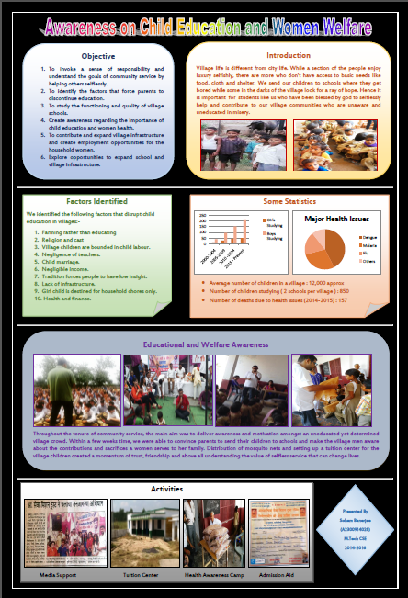

**3. Funds gathered and donated to the NGO**

